Federation cartoon
Examine the source to answer the inquiry question:
What colonial issues contributed to the development of Australia’s Federation?
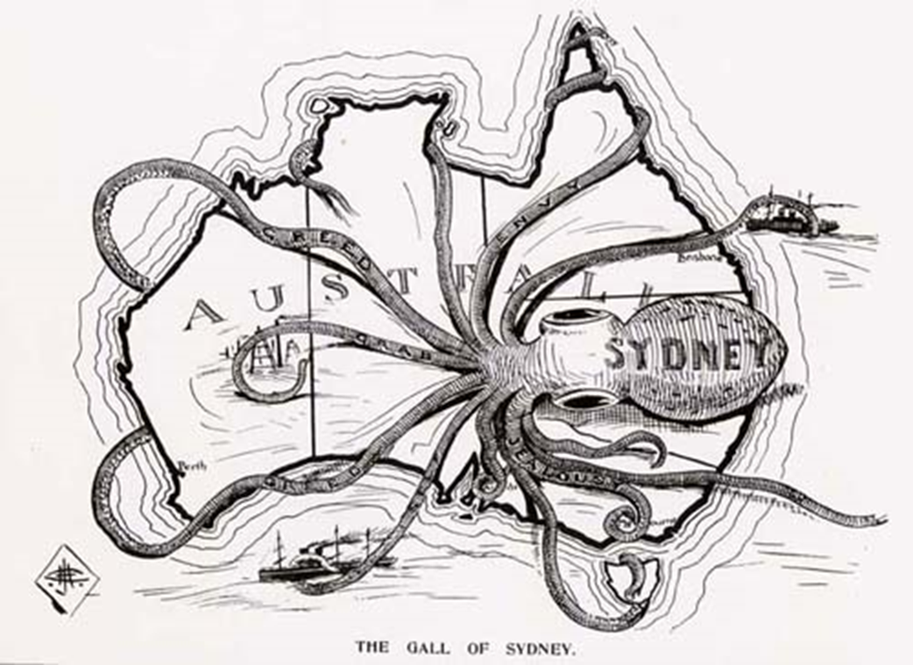
'The gall of Sydney,' Critic, 18 March 1899 Courtesy State Library of South Australia
http://www.slsa.sa.gov.au/federation/slides/1/5gall_of_sydney.htm
Other colonies were not impressed when they found out that the Federal capital was to be sited in New South Wales, even if it was to be located 100 miles from Sydney.
Identify the origin, purpose and perspectives to help answer the inquiry question.
Use a source analysis table if you need some help.
Use the questions below to help you answer the focus question.
Questions
What is the origin of the source?
What was happening at the time the cartoon was made?
What visual and written features are in the source?
What is the main idea of the source?
What perspectives are shown in the source?
What is the purpose of the source?

